**ASSIGNMENT NO. 11**

**AIM :-** Write 80387 ALP to obtain: i) Mean ii) Variance iii) Standard Deviation Also plot the histogram for the data set. The data elements are available in a text file.

**APPARATUS :**

* Core 2 duo/i3/i5/i7 - 64bit processor
* OS – ubuntu 32bit/64bit OS
* Assembler used –nasm (the netwide assembler)
* Editor Used – gedit

**THEORY :**

**1. Introduction:**

1. 8087 was the first math coprocessor for 16-bit processors designed by Intel. It was built to pair with 8086 and 8088.
2. The purpose of 8087 was to speed up the computations involving floating point calculations.
3. Addition, subtraction, multiplication and division of simple numbers is not the coprocessor’s job.
4. It does all the calculations involving floating point numbers like scientific calculations and algebraic functions.
5. By having a coprocessor, which performs all the calculations, it can free up a lot of CPU’s time.
6. This would allow the CPU to focus all of its resources on the other functions it has to perform.
7. This increases the overall speed and performance of the entire system.
8. This coprocessor introduced about 60 new instructions available to the programmer.
9. All the mnemonics begin with “F” to differentiate them from the standard 8086 instructions.
10. For e.g.: in contrast to ADD/MUL, 8087 provide FADD/FMUL.
11. Math coprocessor is also called as:
    * Numeric Processor Extension (NPX)
    * Numeric Data Processor (NDP)
    * Floating Point Unit (FPU)

**2. ARCHITECTURE OF 8087**

T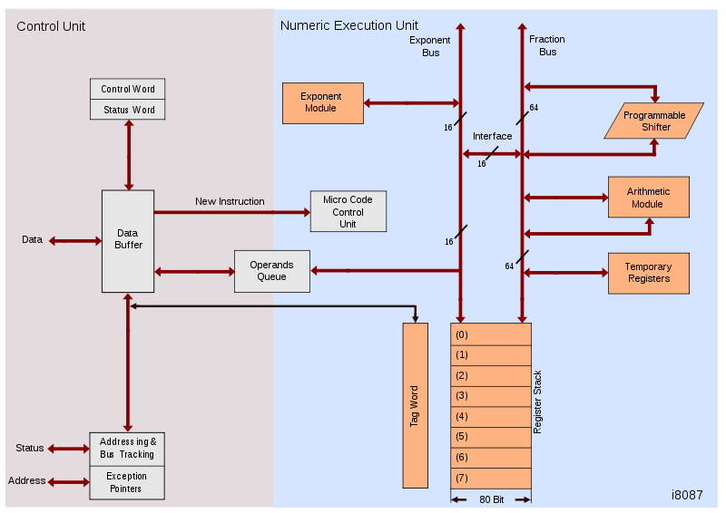he internal structure of 8087 coprocessor is divided into two major sections:

* **Control Unit (CU)**
* **Numerical Execution Unit (NEU)**

**CONTROL UNIT (CU)**

* It interfaces coprocessor to the microprocessor system bus.
* It also synchronize the operation of the coprocessor and the microprocessor.
* This unit has a Control Word, Status Word and Data Buffer.
* If an instruction is ESC instruction, then coprocessor executes it.
* If not, then microprocessor executes.

**NUMERIC EXECUTION UNIT (NEU)**

* This unit is responsible for executing all coprocessor instructions.
* It has an 8 register stack that holds the operands for instructions and result ofinstructions.
* The stack contains 8 registers that are 80-bits wide.
* Numeric data is transferred inside the coprocessor in two parts:
  + 64-bit mantissa bus
  + 16-bit exponent bus

**3. INSTRUCTION SET**

The 8087 instruction mnemonics begins with the letter F which stands for Floating point and dis- tinguishes from 8086. These are grouped into Four functional groups. The 8087 detects an error condition usually called an exception when it executing an instruction it will set the bit in its Status register.

* Data Transfer Instructions.
* Arithmetic Instructions.
* Compare Instructions.
* Transcendental Instructions. (Trigonometric And Exponential)

**A. DATA TRANSFERS INSTRUCTIONS**

**REAL TRANSFER**

FLD Load real

FST Store real

FSTP Store real and pop

FXCH Exchange registers

**INTEGER TRANSFER**

FILD Load integer

FIST Store integer

FISTP Store integer and pop

**PACKED DECIMAL TRANSFER(BCD)**

FBLD Load BCD

FBSTP Store BCD and pop

**B. ARITHMETIC INSTRUCTIONS**

**Addition**

FADD Add real

FADDP Add real and pop

FIADD Add integer

**Subtraction**

FSUB Subtract real

FSUBP Subtract real and pop

FISUB Subtract integer

FSUBR Subtract real reversed

FSUBRP Subtract real and pop

FISUBR Subtract integer reversed

**Multiplication**

FMUL Multiply real

FMULP Multiply real and pop

FIMUL Multiply integer

**Advanced (Other Arithmetic Operations)**

FABS Absolute value

FCHS Change sign

FPREM Partial remainder

FPRNDINT Round to integer

FSCALE Scale

FSQRT Square root

FXTRACT Extract exponent and mantissa.

**C. COMPARE INSTRUCTIONS**

**Comparison**

FCOM Compare real

FCOMP Compare real and pop

FCOMPP Compare real and pop twice

FICOM Compare integer

FICOMP Compare integer and pop

FTST Test ST against +0.0

FXAM Examine ST

**D. TRANSCENDENTAL INSTRUCTION**

**(TRIGONOMETRIC AND EXPONENTIAL)**

**Transcendental**

FPTAN Partial tangent

FPATAN Partial arctangent

F2XM1 2x - 1

FYL2X Y log2X

FYL2XP1 Y log2(X+1)

**Load Constant Instruction**

FLDZ Load +0.0

FLDI Load+1.0

FLDPI Load π

FLDL2T Load log210

FLDL2E Load log2e

FLDLG2 Load log102

FLDLN2 Load loge2

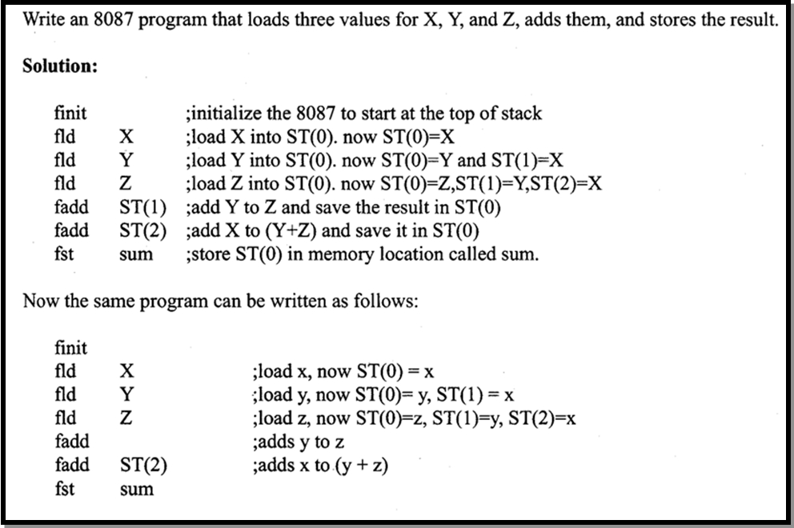

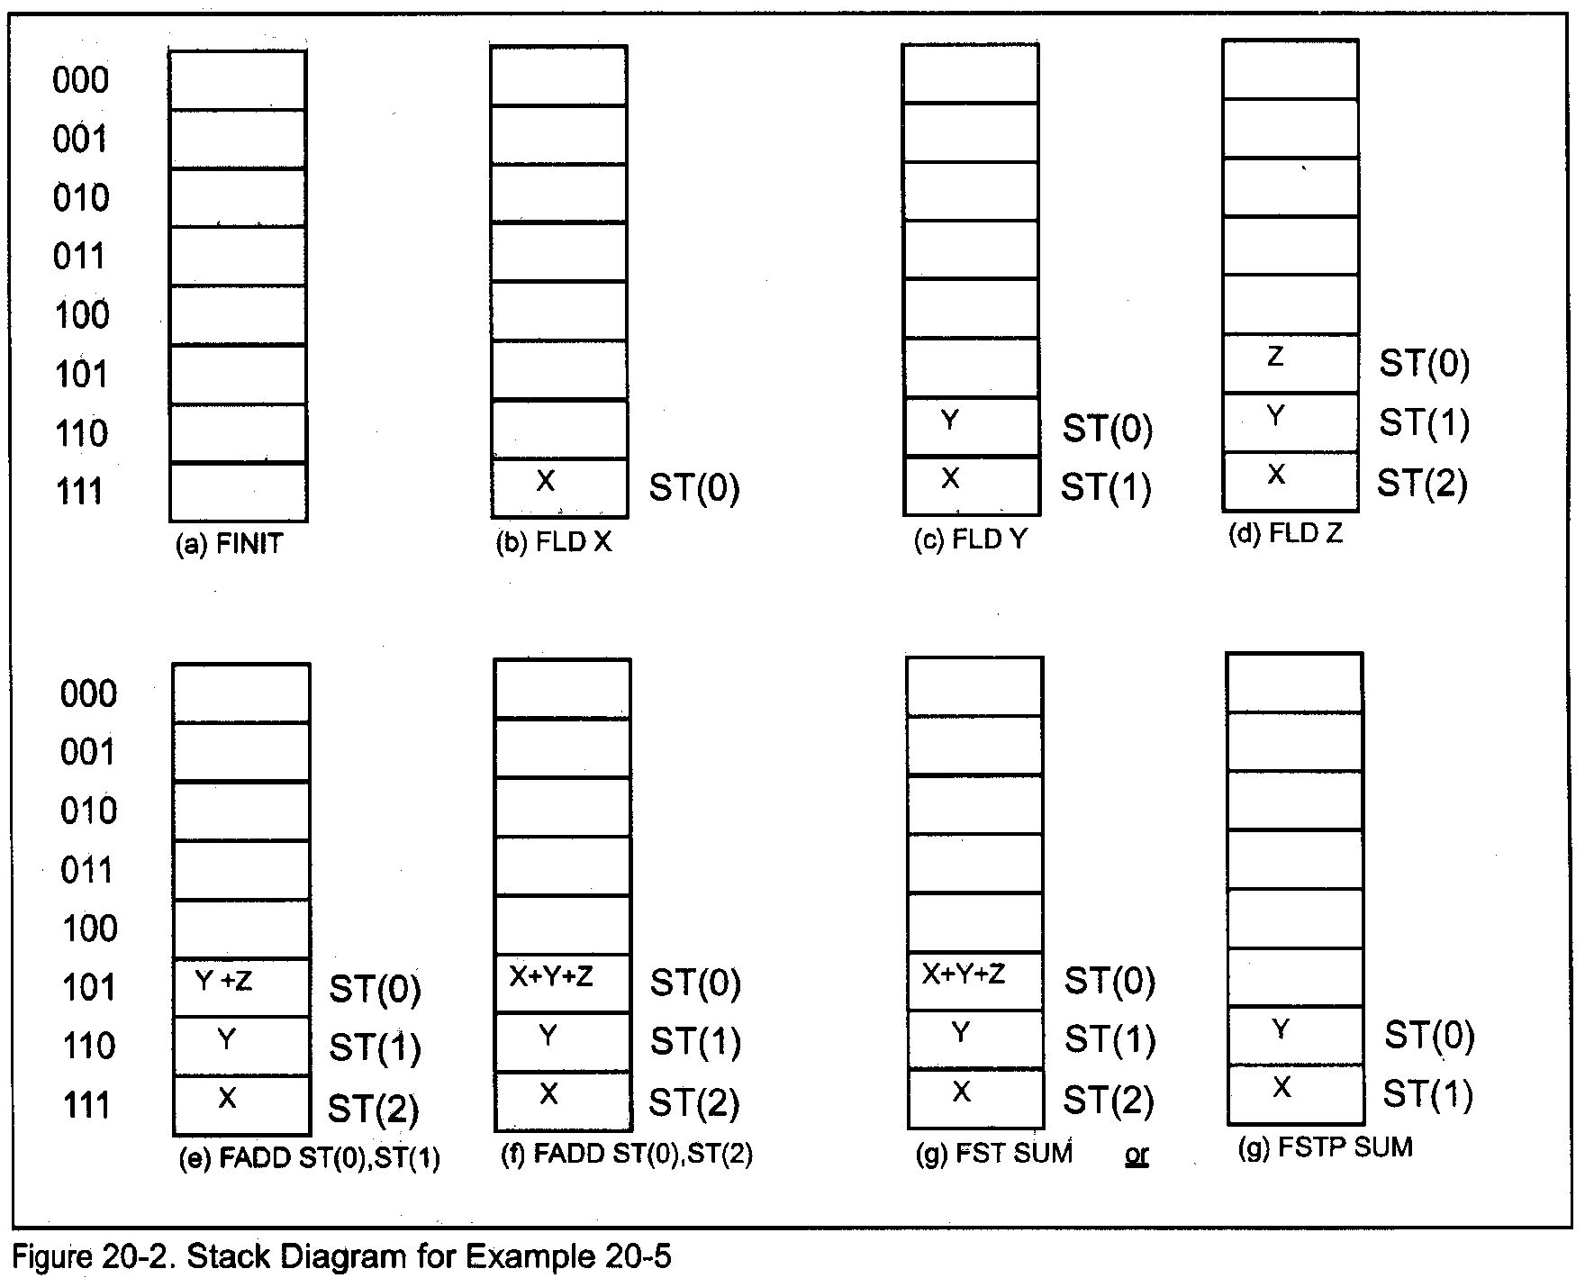

**CONCLUSION:**

_______________________________________________________________

______________________________________________________________________________________________________________________________